**RYANA CALENDARS**

**User guide**

|  |  |  |
| --- | --- | --- |
| **Supervisor** | **Zaman**  **220901e**  **Ryana Calendars** | |
| **Batch** |
| **Group** |
| **Serial No.** | **Enrolment No.** | **Student Name** |
| 1 | Aashir Azeem | 1418436 |
| 2 | Zaayan Zubair | 1422404 |
| 3 | Taha | 1418454 |
| 4 | Zohair | 1422397 |

|  |
| --- |
| User guide |

"Never miss a beat with our calendar!" This website is basically based on calendars. Simplify your life and stay on top of every important date and event with our calendar website. Whether it's for work, family, or personal commitments, our comprehensive calendar will keep you organized and on schedule like never before.

1. Top layout

This is the top of the page.

* Users can know about the website by clicking on about us button.
* Users can get in touch with the admin by registering themselves from this page.



1. Home page

This page contains our services and products.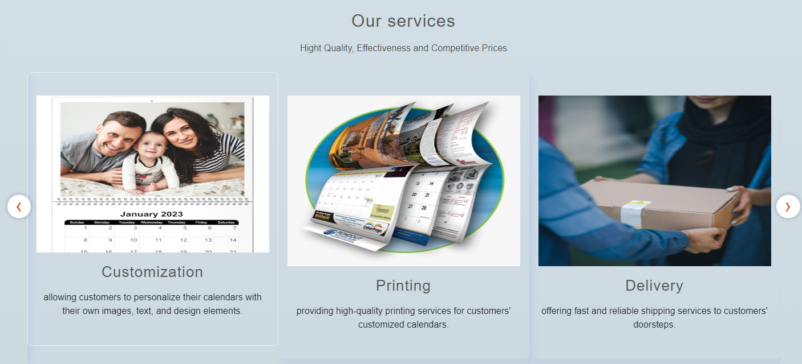

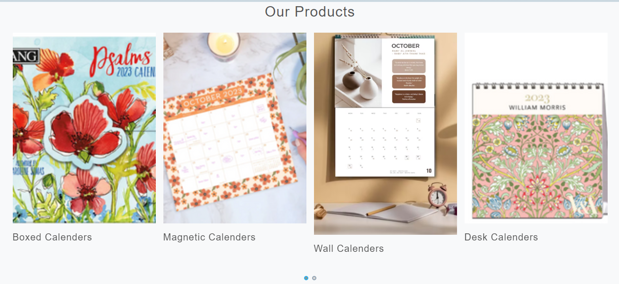

1. Products

This is our products page.

* In this page users can get different types of calendars, journals and planners.
* Users can also see the description of every single product by clicking on read more and can also download the description by clicking on download button.

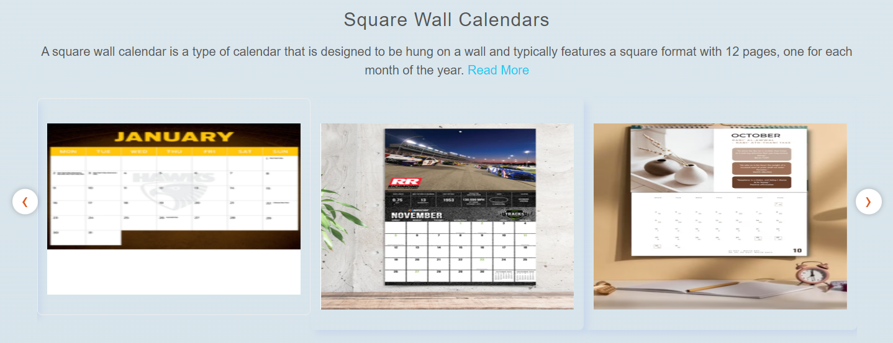

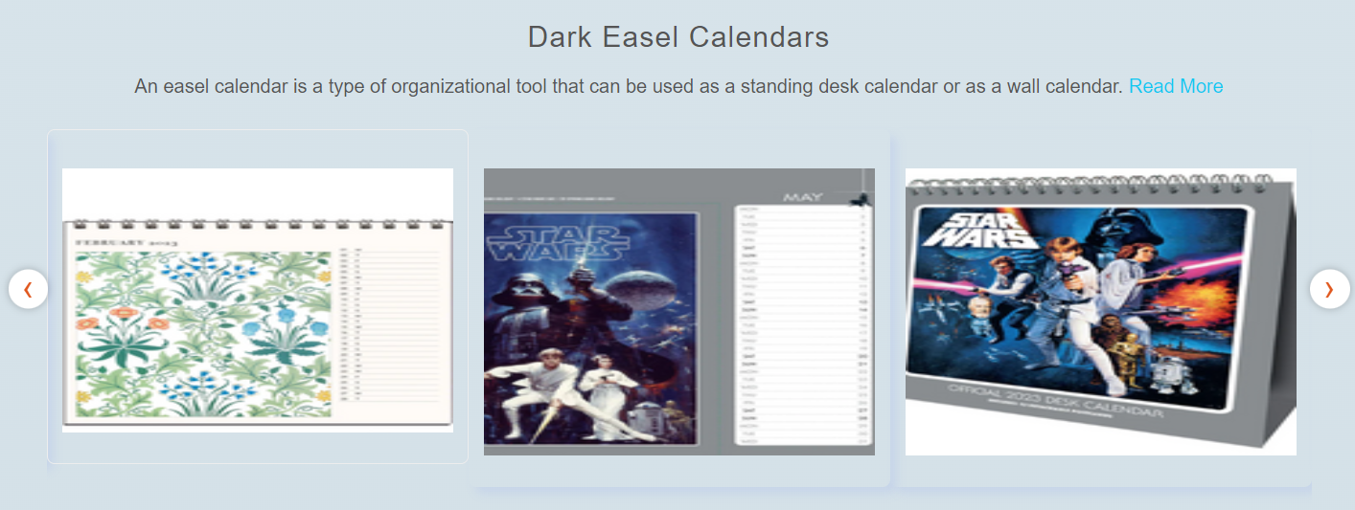

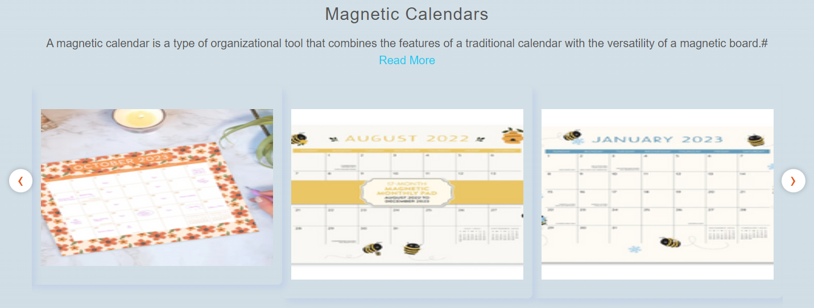

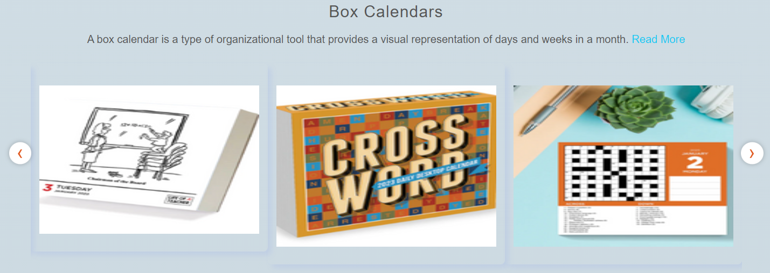

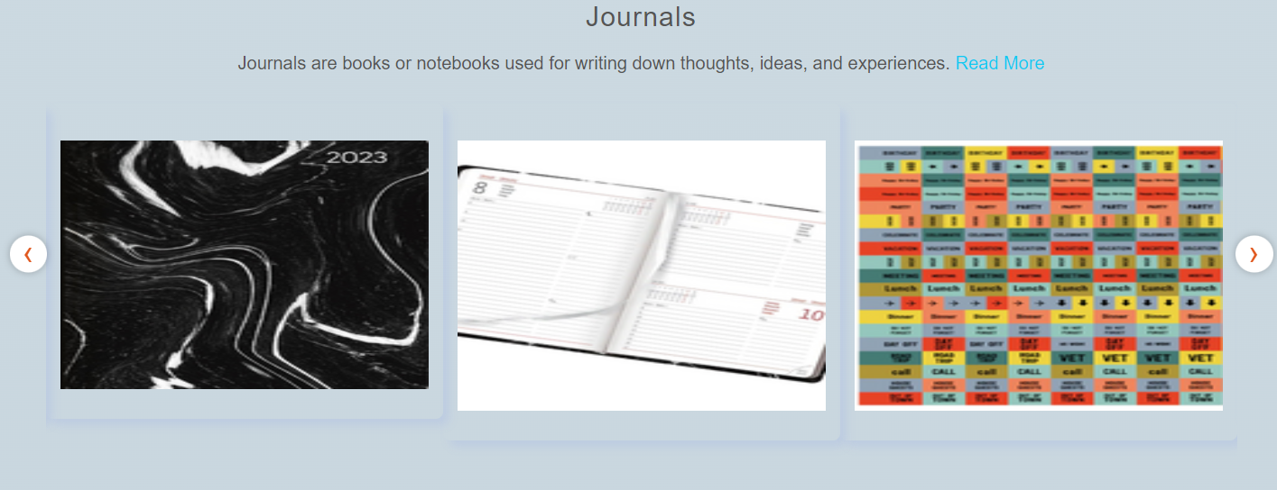

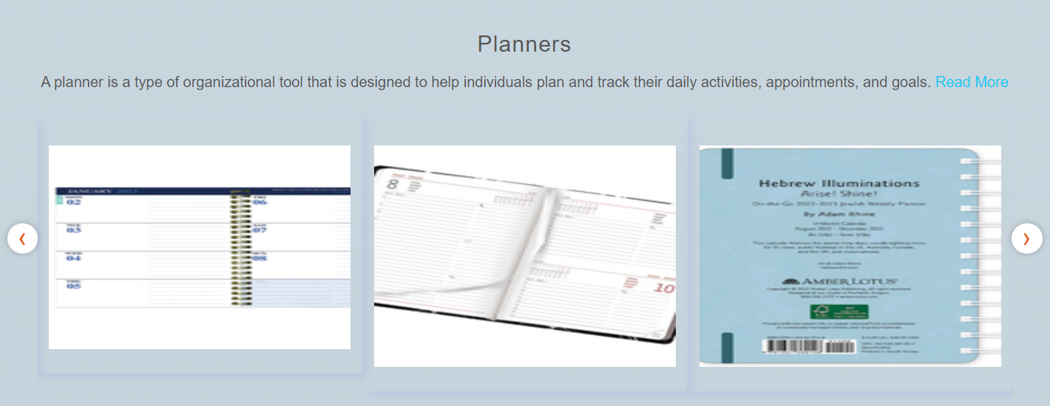

1. Contact page

This is the contact page

* In this page users can get in touch with us.
* They can leave their comments.

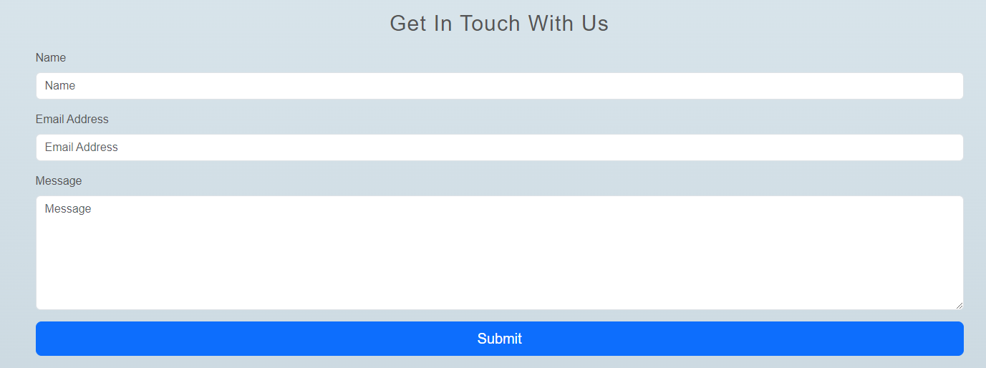

1. About page

This is the about us page

* This page has some information about us.

1. Login/register

* In this page users can first register their-selves, and then login.
* By logging in users can get full access to our website.

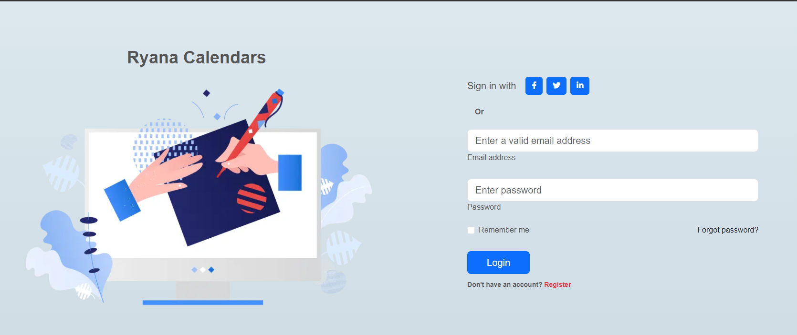

1. Bottom layout

This is the bottom of the page

* It has some links of our products.
* It has the location of our shop.
* It has our social media accounts from users can further interact with us.

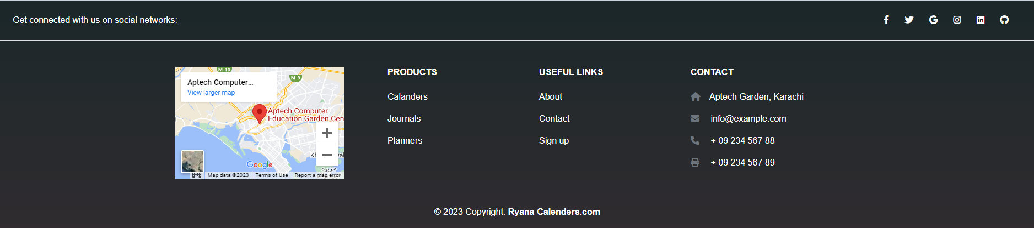

Thank you for reading the documentation.